Correction TP 2 (Calc)

Interface

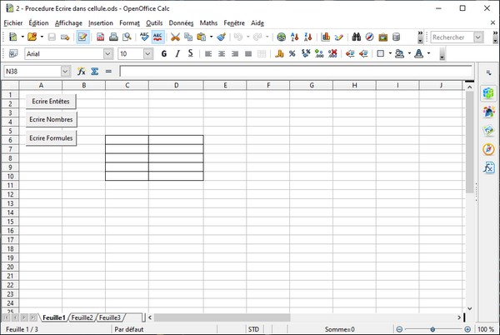

Code
REM ***** BASIC *****
Option Explicit
Dim LesFeuilles as Object
Dim PremiereFeuille as Object
Dim Cellule as Object

Sub Definition
LesFeuilles = ThisComponent.Sheets
PremiereFeuille = LesFeuilles.GetbyName("Feuille1")
End Sub

Sub EcrireEntetes
Definition
Cellule = PremiereFeuille.getCellRangeByName("C6")
Cellule.CellBackColor = RGB(200,200,255)
Cellule.String = "Nombre :"
Cellule = PremiereFeuille.getCellRangeByName("D6")
Cellule.CellBackColor = RGB(200,200,255)
Cellule.String = "Racine carrée:"
End Sub

Sub EcrireNombres
Dim i as byte
Definition
For i=1 to 4
Cellule = PremiereFeuille.GetCellByPosition(2,5+i)
Cellule.CellBackColor = RGB(255,255,204)
Cellule.Value = 100*i
Next i
End Sub

Sub EcrireFormules
Dim i as byte
Definition
For i=1 to 4
Cellule = PremiereFeuille.GetCellByPosition(3,5+i)
Cellule.CellBackColor = RGB(255,255,204)
'Soit en Anglais
'Cellule.Formula="=SQRT(C"+ Mid(str(6+i),2)
'soit en Français
Cellule.FormulaLocal="=RACINE(C"+ Mid(str(6+i),2)
Next i
End Sub

